**PROJECT #1: Switching Element Problem**

**COURSE: ESE 546 Network Algorithms, Fall 2015, Prof. T. Robertazzi**

**NAME: PREM SHANKAR**

**STUDENT ID: 110500038**

**Description of Program**

The project aims at discrete simulation of switching elements with 10 inputs and 3 outputs similar to figure Fig. 1 given below. Time is slotted on all inputs and outputs with independent probability of packets arriving is p. The program mimics the operation of switch and collect statistics.

Switching

Element

*p*

*p*

*p*

*p*

*p*

*p*

*p*

*p*

*p*

*p*

Fig. 1. Switching Element

The program is implemented using MATLAB and in two phases. Phase 1 implements the simulation part of the problem while Phase 2 deals with the theoretical solution to the problem. Initially, a loop for calculation of throughput and number of dropped packets against all the probabilities (starting from 0.02 till 1) is used.

Inside this loop, phase 1 of the solution is implemented where packets for 1000 timeslots are generated and throughput as well as number of dropped packets are calculated for each timeslot. Thereafter, average of the throughput and number of dropped packets are calculated for 1000 timeslots and plotted against each value of p (probability).

In phase two of the solution, the loop of probability from 0.02 to 1 runs initially. Thereafter, for each value of p, throughput and number of dropped packets are calculated using below theoretical equation:

Average # of busy output = 1. $\left({10 \atop 1}\right)p^{1}{(1-p)}^{9}$ +2 $.\left({10 \atop 2}\right)p^{2}{(1-p)}^{8}$ + $\sum_{m=3}^{10}{\left({10 \atop m}\right)p^{m}{(1-p)}^{10-m}}$

Average # of packets dropped = $\sum_{m=4}^{10}{(m-3)\left({10 \atop m}\right)p^{m}{(1-p)}^{10-m}}$

Finally, two graphs are plotted against probability; one comparing throughput obtained from simulation and equation while the other comparing number of dropped packets obtained from simulation and equation.

**SOURCE CODE**

**Name of Language Used: MATLAB**

**Main Program (Project1.m File)**

%% Theoretical Part

p=0; i = 1;

prob = 0.02:0.02:1;

drops = zeros(1,50);

throughput = zeros(1,50);

while p<=1

p = p + 0.02;

[t,d] = Output(p); %function call to find Throughput and Dropped packets

drops(i) = d;

throughput(i) = t;

i = i+1;

end

%% Simulation part

simulation = 1000;

x = 1;

t_sim = zeros(1,50);

d_sim = zeros(1,50);

for j = 0.02:0.02:1

t = 0;

d = 0;

for i= 1:simulation

packets = 0;

p = rand(1,10);

for k = 1:10

if(p(k) <= j)

packets = packets+1; %calculate number of packets for %each time slot

end

end

if(packets<4)

t = t + packets; %calculate Throughput

else

t = t+3;

d = d + packets - 3; %calculate packets dropped

end

end

total = t;

t = t/simulation; %Average number of busy oputputs for 1000 timeslots

t_sim(x) = t;

d = d/simulation; %Average dropped packets for 1000 timeslots

d_sim(x) = d;

x = x + 1;

end

%% Plot Graphs

p1 = plot(prob,throughput,'g',prob,t_sim,':xk');

title('Simulated VS Theoretical');

xlabel('Probability');

ylabel('Average Number of Busy Output');

p1(1).LineWidth = 2;

p1(2).LineWidth = 2;

p1(1).Marker = '*';

figure

p2 = plot(prob,drops,'g',prob,d_sim,':xb');

title('Simulated VS Theoretical');

xlabel('Probability');

ylabel('Number of packets dropped');

p2(1).LineWidth = 2;

p2(2).LineWidth = 2;

p2(1).Marker = '*';

**Subroutine (Output.m): function to calculate throughput and dropped packets using equation**

function[throughput, drops] = Output(p)

output = 0;

output1 = 0;

drops = 0;

for i=1:10

if(i<4)

output= output+ i*nchoosek(10,i)*(p.^i)*((1-p).^(10-i));

else

output1 = output1 + nchoosek(10,i)*(p.^i)*((1-p).^(10-i));

drops = drops + (i-3)*nchoosek(10,i)*(p.^i)*((1-p).^(10-i));

end

end

throughput = output + 3*output1;

end

**GRAPHS**

1. **Average Number of Busy Outputs VS Probability**

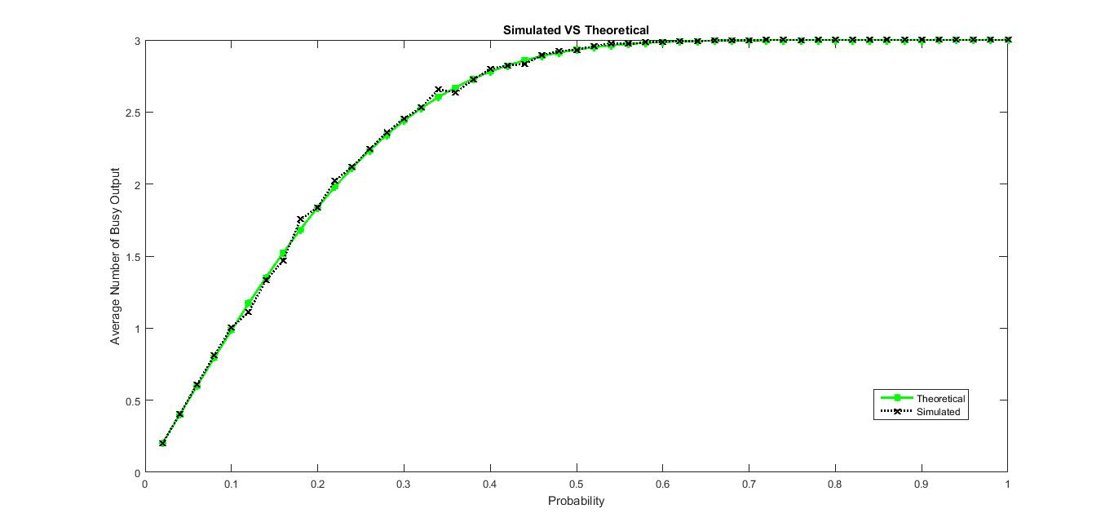

1. **Average Number of Dropped Packets VS Probability**

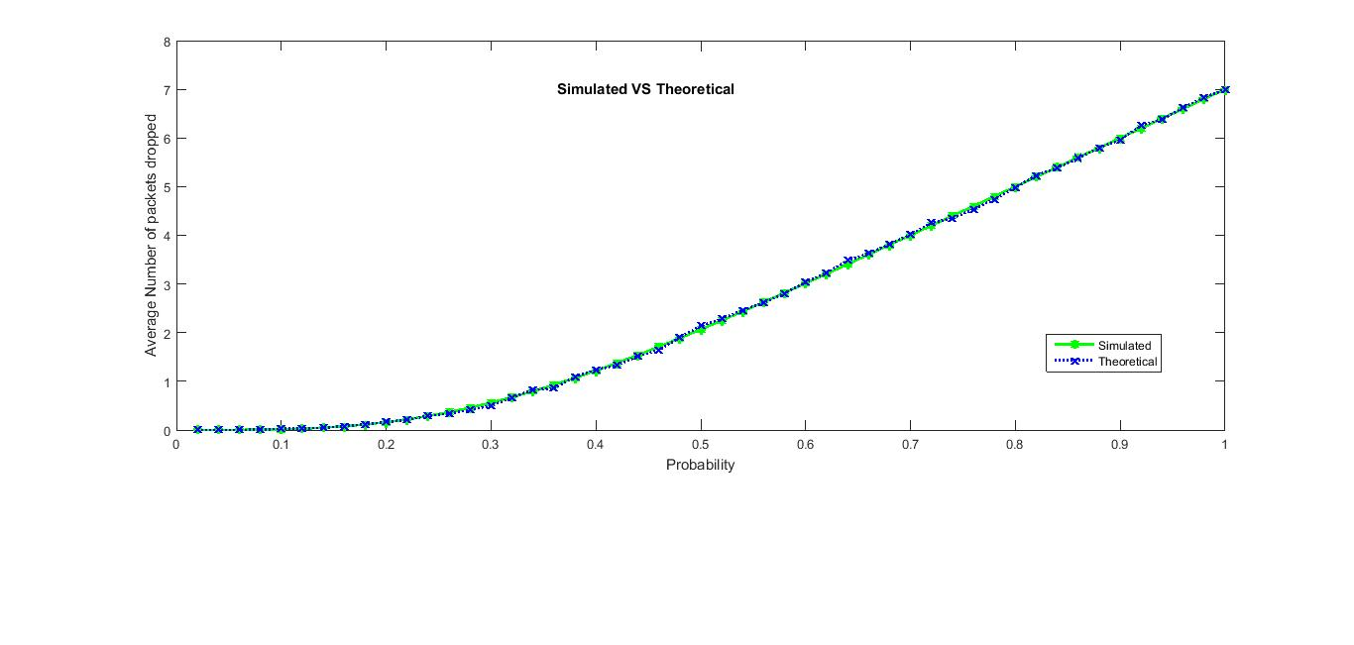

**CONCLUSION**

The performance of switching element can be evaluated using two prime performance parameters which has been found both from simulation as well as equations:

1. **Average number of busy output**: It denotes the throughput of the system which increases with increase in probability of arrival of packets. Therefore, the performance of the switching element increases with increase in probability.
2. **Average number of dropped packets**: It increases with increase in probability of packet arrival as evident from graph. Therefore, the performance of the system decreases with increase in probability as packet loss may incur delays due to retransmission.

Therefore, the overall performance depends on both the factors and we need to choose between the two for best performance which satisfies our requirements.